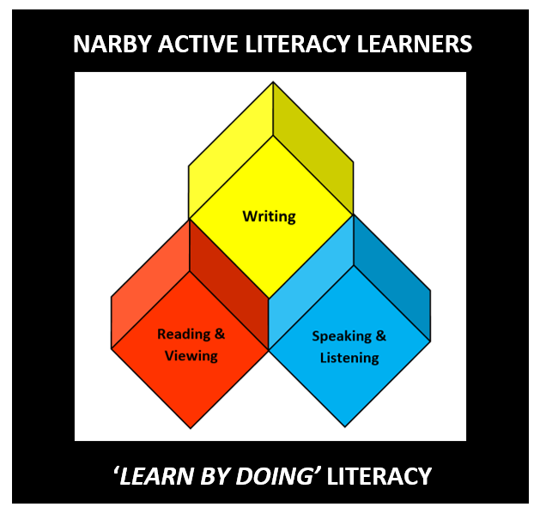
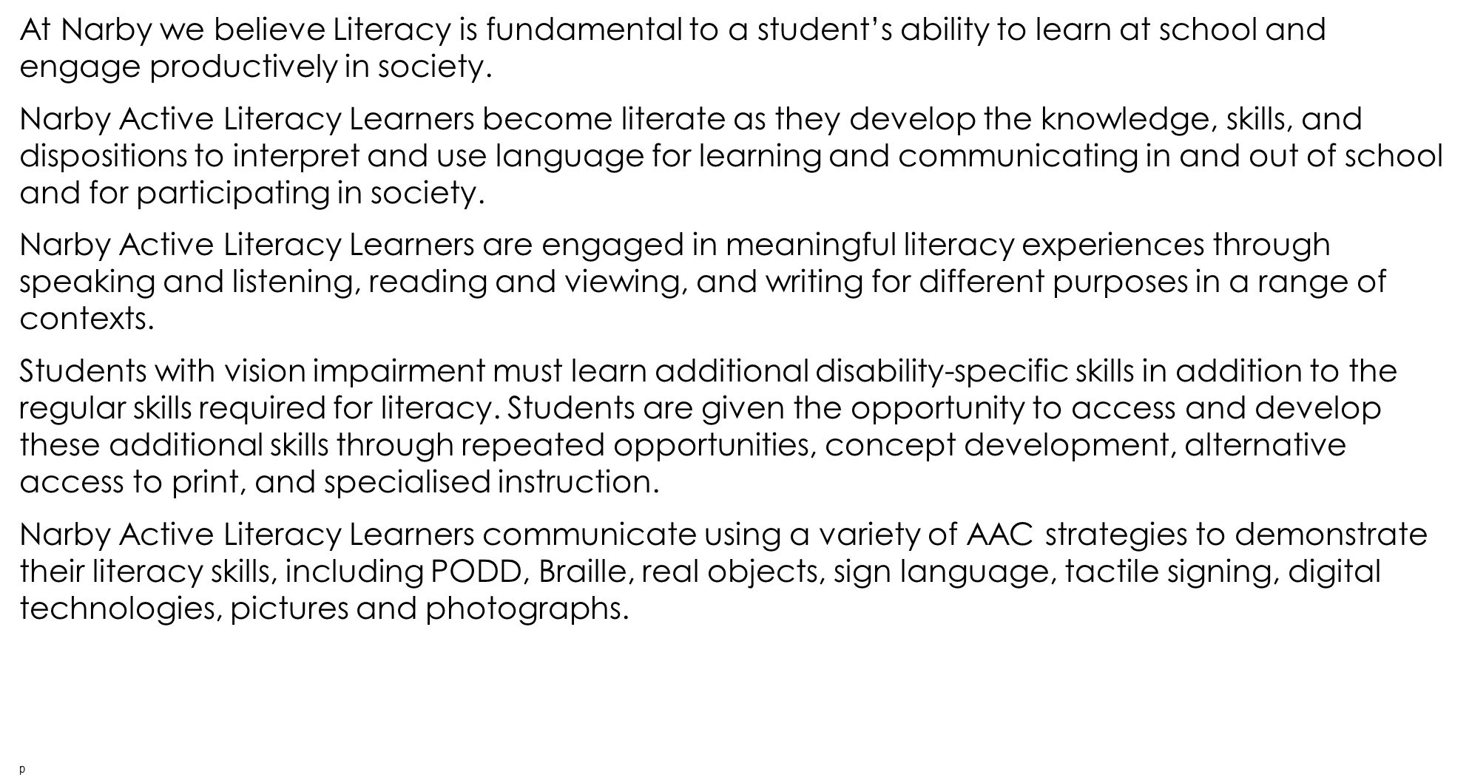
Narby Active Speakers and Listeners
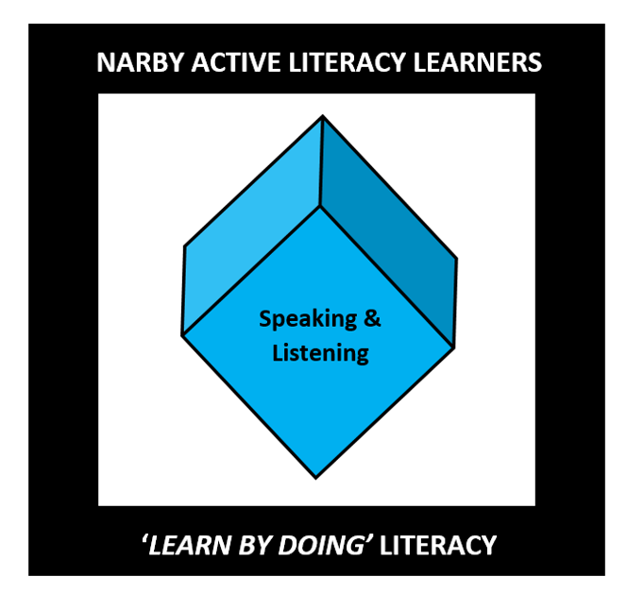 | - Narby Active Speakers and Listeners use oral language and AAC strategies to communicate with others in a range of contexts, and listen actively and attentively when interacting with others.  - Narby Active Speakers and Listeners build meaning from a variety of oral, aural, visual, tactile, electronic and multimodal texts through comprehension and vocabulary knowledge.  - Narby Active Speakers and Listeners develop two-way interaction to clarify and create understanding. They select appropriate language to demonstrate understanding, express ideas, and share information.  - Narby Active Speakers and Listeners learn vision impairment specific skills of compensatory communication modes, use of access technology, social interaction skills, and concept development related to being effective speakers and listeners.
This involves skills in:
- Listening – includes active listening processes to access and understand language structures of spoken texts for audiences and specific purposes
- Interacting – questioning and using language to share information and negotiate meaning and outcomes within a range of contexts and purposes
- Speaking – selecting language to express and share ideas appropriate to audience, purpose and task, and develop skills and techniques in fluency
- Comprehension – responding to, interpreting, analysing and evaluating texts
- Vocabulary – understand the meaning of spoken words and use them to create texts.
Narby Active Readers and Viewers
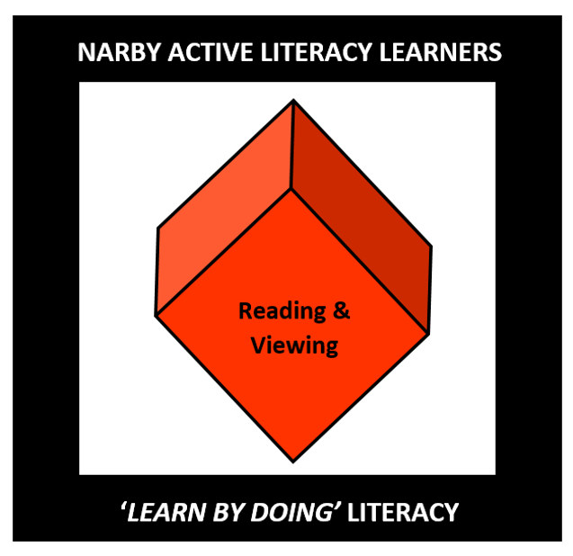 | - Narby Active Readers and Viewers navigate texts to create meaning. This involves learning experiences in reading texts, fluency, vocabulary, comprehension, phonemic awareness, phonic knowledge and word recognition, and concepts about print.  - Narby Active Readers and Viewers learn vision impairment specific skills of compensatory communication modes, use of access technology, visual efficiency skills, pre-Braille skills, and concept development related to being effective readers and viewers.
This involves skills in:
- Reading texts - recognising words automatically, reading in a phrased and fluent way and navigating texts to create meaning
- Fluency – becoming faster, smoother, more accurate and expressive
- Vocabulary – understanding the meaning of spoken and written words
- Comprehension – responding to, interpreting, analysing and evaluating texts
- Phonemic awareness –hearing and manipulating sounds in spoken language
- Phonic knowledge and word recognition –making the connection between sounds and letters when reading and spelling
- Concepts about print – understanding and using conventions and concepts about print.

Narby Active Writers
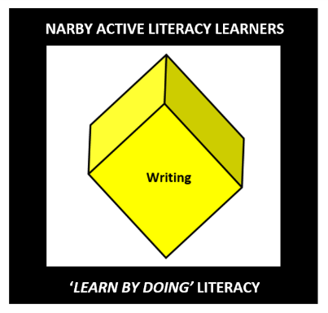 | - Narby Active Writers create texts using a variety of composition methods for a range of purposes. This involves learning about crafting ideas and different types of writing. They make choices about vocabulary, grammar, punctuation and spelling.  - Narby Active Writers learn vision impairment specific skills of compensatory communication modes, use of access technology, pre-Braille skills, and concept development related to being effective writers.
- Narby Active Writers create a range of written, oral, digital, and multimodal texts.
This involves skills in:
- Creating texts by crafting ideas, selecting text forms and features, and vocabulary, for a range of purposes including informative, persuasive and imaginative
- Grammar - making choices at word group, sentence and whole text level
- Punctuation – using punctuation in texts they produce for clarity and ease of reading
- Spelling – selecting and arranging letters to accurately form words to create meaning
- Handwriting and keyboarding – composing with increasing speed, accuracy and fluency.

