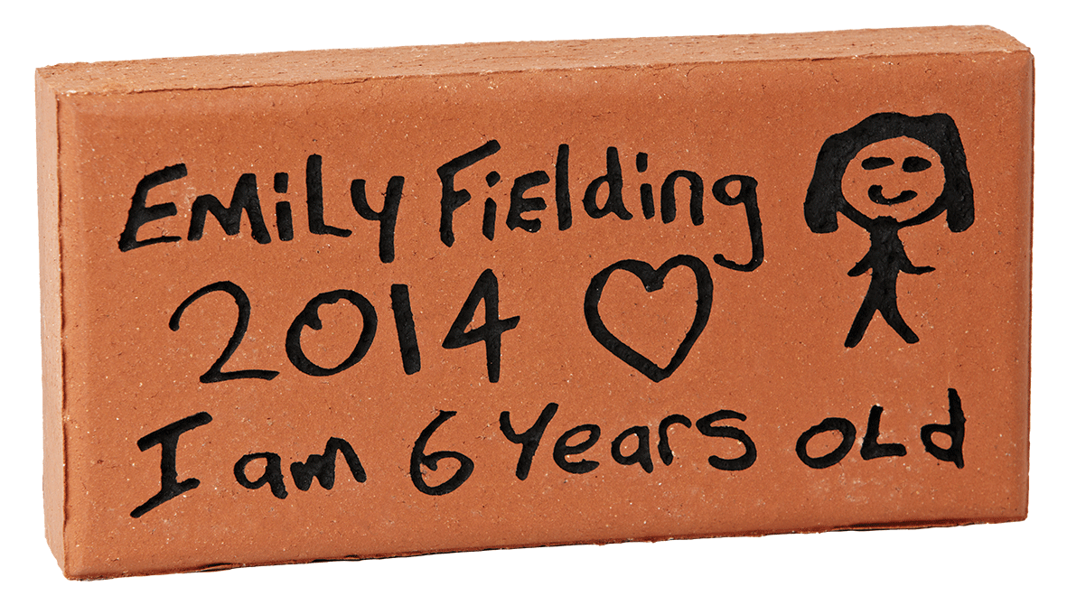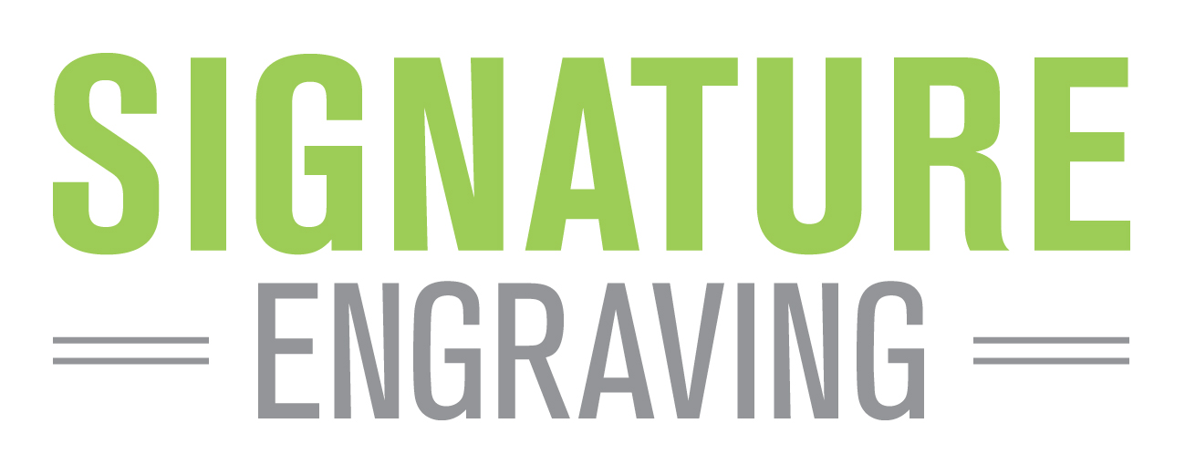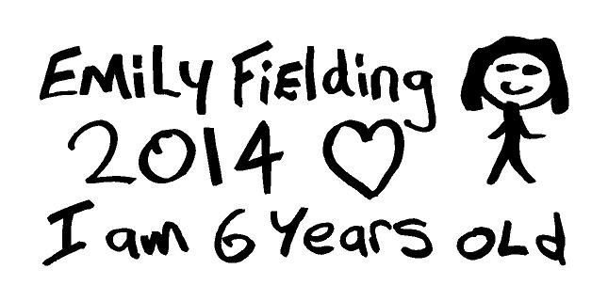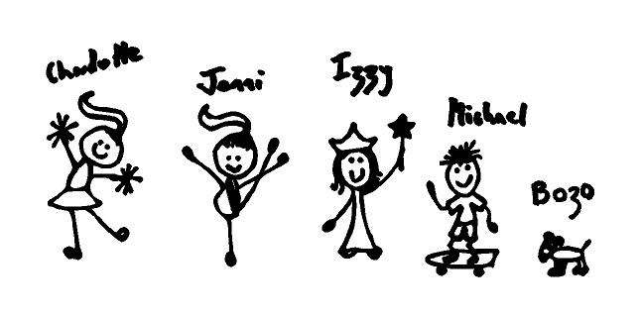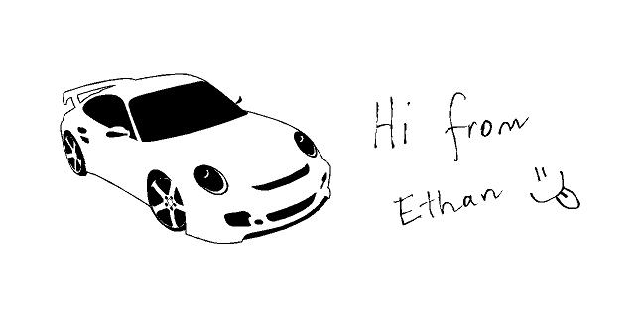



© 2018 Signature Engraving - www.signature-engraving.com.au V: 2.0

HAND DRAWN

TEMPLATE

Your donation of $50 entitles you to have your name engraved into a paver as a lasting record of your valued support. The paver will be permanently installed as a part of the

**Narbethong Community Path**

proudly representing your support to the students of Narbethong.

OFFER: $50

HAND DRAWN DETAILS

Please follow the instructions below and overleaf to ensure your drawing details are not lost during the engraving process.

1. If you do not use the template over the page, keep your drawing within the dimensions of 190mm wide x 100mm deep.
2. ONE NAME PER PAVER.
3. Artline 70 ‘High Performance’ permanent marker is the preferred and recommended marker to use.
4. NO colour pencils, colour textas, Biro’s etc will be accepted.

See over for further instructions and template.

As a part of our fundraising efforts in 2018, we would like to create a *Narbethong Community Path* surrounding our sensory garden. The path will acknowledge friends, family and community connections both now and for many years to come.

For engraving details please complete the form on the reverse.

Offer closes on the 2nd June 2018

Please copy and pass on to any friends & family.

**We Need Your Support!**

|  |  |  |  |  |  |  |  |
| --- | --- | --- | --- | --- | --- | --- | --- |
| Contact Name | | | | | | Phone | |
|  | | | | | | ( ) | |
| Street | | | | | | | |
|  | | | | | | | |
| City | | | | | | State | Post Code |
|  | | | | | |  |  |
|  | |  |  |  |  | Our Donation | |
|  |  |  |  |  |  | $ | |

NARBETHONG STATE SPECIAL SCHOOL

Simply fill out this form and return along with full payment by cash, cheque or bank transfer to:

Narbethong General Account – BSB 064-128 Account No. 00090103

*Please reference your payment with your name.*

**Narbethong State Special School**

**25 Sailsbury Street**

**Buranda QLD 4102**

PLEASE FOLLOW THESE SIMPLE STEPS WHEN CREATING YOUR IMAGE.

1. ONE NAME PER PAVER.

1. 2. Draw your image using a good quality medium thickness black marker pen (about 2mm thick).   
    eg Artline 70 ‘High Performance’ marker.  
    **Do not use a ballpoint pen, coloured texta or pencils!**
2. 3. Make sure you rub out any pencil lines as these will show up on the finished paver.
3. 4. Do not include computer-generated or pasted pictures.
4. The hand drawn image engraving process is set up to engrave hand drawn images only.

**Administrator note: Please photocopy this page for your records, cut out the drawing below   
and send the ORIGINAL to Signature Engraving.**

**PHOTOCOPY THIS PAGE FOR EACH HAND DRAWN PAVER.**

**PLEASE ENSURE THAT YOUR DRAWING DOES NOT TOUCH OR GO OUTSIDE OF THE BORDER**

THIS IS NOT OK ✗

• Do not include computer-generated or pasted pictures

• The process is set up to engrave hand drawn images only

THIS IS NOT OK ✗

• Too many names

• Illustrations too detailed

• Information gets lost

ENGRAVING DETAILS



HAND DRAWN

TEMPLATE

100mm high x 190mm wide

**SAMPLE 1**

**SAMPLE 2**

**SAMPLE 3**

THIS IS OK ✓

• Good clean writing

• Simple illustrations

✗

✗

✗

✗

✗