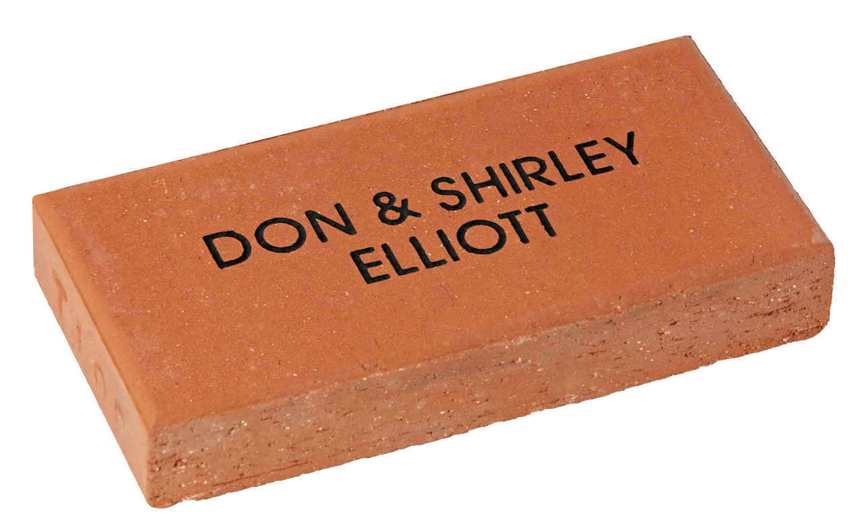

Simply fill out this form and return along with full payment by cash, cheque or bank transfer to:

Narbethong General Account – BSB 064-128 Account No. 00090103

*Please reference your payment with your name.*

As a part of our fundraising efforts in 2018, we would like to create a *Narbethong Community Path* surrounding our sensory garden. The path will acknowledge friends, family and community connections both now and for many years to come.

SINGLE Name PAVER TEMPLATE

|  |  |  |  |  |  |  |  |  |  |  |  |  |  |  |  |  |  |  |  |  |  |  |  |  |  |  |  |  |  |  |  |
| --- | --- | --- | --- | --- | --- | --- | --- | --- | --- | --- | --- | --- | --- | --- | --- | --- | --- | --- | --- | --- | --- | --- | --- | --- | --- | --- | --- | --- | --- | --- | --- |
| **LINE 1** |  |  |  |  |  |  |  |  |  |  |  |  |  |  |  |  |  |  |  |  |  |  |  |  |  |  |  |  |  |  |  |
|  |  |  |  |  |  |  |  |  |  |  |  |  |  |  |  |  |  |  |  |  |  |  |  |  |  |  |  |  |  |  |  |
| **LINE 2** |  |  |  |  |  |  |  |  |  |  |  |  |  |  |  |  |  |  |  |  |  |  |  |  |  |  |  |  |  |  |  |
|  |  |  |  |  |  |  |  |  |  |  |  |  |  |  |  |  |  |  |  |  |  |  |  |  |  |  |  |  |  |  |  |
| **LINE 3** |  |  |  |  |  |  |  |  |  |  |  |  |  |  |  |  |  |  |  |  |  |  |  |  |  |  |  |  |  |  |  |

**Narbethong State Special School**

**25 Sailsbury Street**

**Buranda QLD 4102**

|  |  |  |  |  |  |  |  |
| --- | --- | --- | --- | --- | --- | --- | --- |
| Company/Contact Name | | | | | | | |
|  | | | | | | | |
| Street | | | | | | | |
|  | | | | | | | |
| City | | | | | | State | Post Code |
|  | | | | | |  |  |
| Phone | |  |  |  |  | Our Donation | |
| ( ) |  |  |  |  |  |  | |

© 2018 Signature Engraving - www.signature-engraving.com.au V:2.0

Please copy and pass on to any friends & family.

**We Need Your Support!**

SINGLE NAME PAVER: **$50 per paver**

Your donation of $50 entitles you to have your name engraved into a paver as a lasting record of your valued support. The paver will be permanently installed as a part of the

**Narbethong Community Path**

proudly representing your support to the students of Narbethong.

Offer closes on 2nd June 2018

NAME PAVER

Please print clearly in block letters. Each box represents a character (letter, number, punctuation mark or space).

Max 16 characters per line, three lines per paver. (No hand drawings.)

ENGRAVING DETAILS

NARBETHONG STATE SPECIAL SCHOOL

